PROGRESS REPORT (WEEK 2)

Project: Design an Autonomous Robot

Task: To design an autonomous robot that is capable of navigating to a predetermined position while avoiding obstacles and firing objects at two targets. This is to be done in the shortest time possible.

Document Version Number: 1

Date: March 4th 2015

Author: Gwyneth Pang

TABLE OF CONTENTS

Gantt Chart……………………………………………………………………………………………………………………………………………1

Mechanical Design………………………………………………………………………………………………………………………………….2

Software Design…………………………………………………………………………………………………………………………………….4

Testing…………………………………………………………………………………………………………………………………………..………4

Plans for the following week…………………………………………………………………………………………………………………5

GANTT CHART

The initial documents have been finished in time. The hardware design was scheduled to be finished on March 4th, in which we have indeed finished the hardware design on March 4th. We only need to get another roll of paper in order to hold the balls, since our previous one broke. Furthermore, the software architecture for each part has been decided, and we only need to put them together and to calibrate them. Thus far, we have been following the Gantt chart. The testing has been ahead of schedule. We have developed a list of potential tests to perform during the testing phase.

MECHANICAL DESIGN

The mechanical design has been finished. The launching system has been implemented sturdily onto a brick and two motors (one for each wheel), along with an ultrasonic sensor on the side, one of the front, and a light sensor on the back. The loading system still needs to be implemented however.

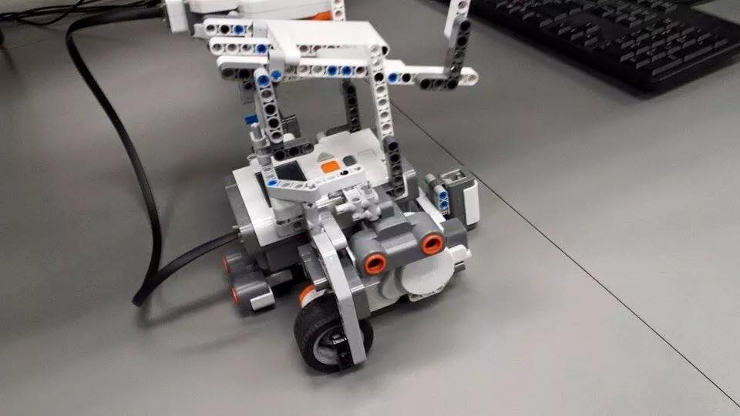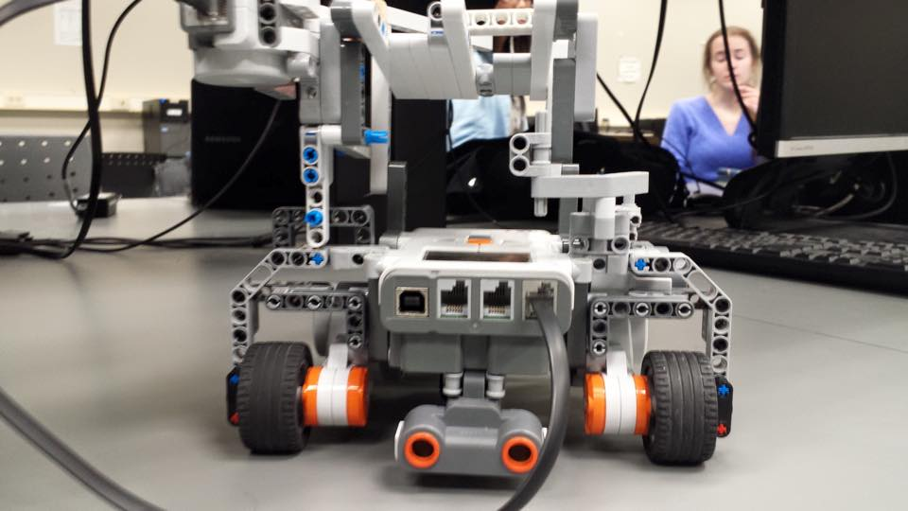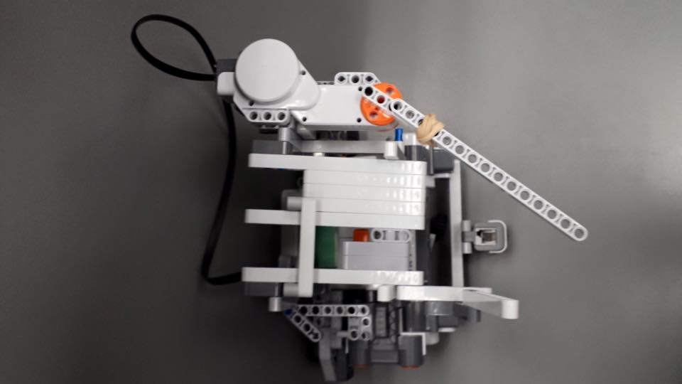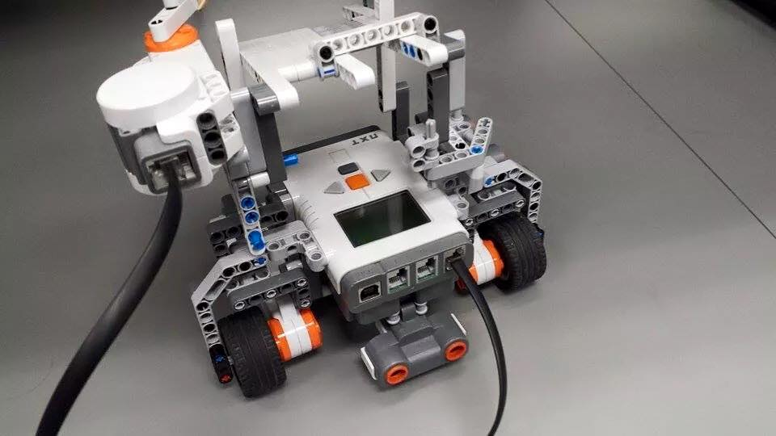

SOFTWARE DESIGN

Every part of the code: odometer, obstacle avoidance, navigation, localization, all have the preliminary software. Details can be found in the week 2 preliminary software architecture files within the week 2 folder. Every part has its own file, with its own progress. Although, every part should at least be functioning. Modifications to the original code that need to be modified include: a differential light sensor, a proper wall follower for the obstacle avoidance, and a differential ultrasonic sensor. These differential sensors need to be implemented due to the changing environment of the competition area.

TESTING

We have started to brain storm on testing ideas, and so far, the result has been the following:

1. Loading and Launching Test

In this test, the robot will have to load a set amount of ping pong balls, and shoot them into a specific area. The data will then be analyzed to determine the strength of the launching system, and its reliability. We may need to use a looser or stronger elastic depending on the results.

1. Mechanical Design Test

In this test, the robot will carry an extra set amount of weights and the ping pong balls in the loading system. It will need to walk a certain distance without dropping the balls, or accidentally launching one. This test will testing the durability of the mechanical design. The extra load will test the sturdiness of the mechanical design. The second part of the test where it needs to walk without dropping the balls, will also test the loading capabilities of the robot, making sure that the robot is able to carry the ping pong balls while running.

1. Navigation and Obstacle Avoidance Testing

In this test, the robot will need to navigate itself to separate points autonomously where we will put random obstacles along its path. The distance will be 1.5x the length of the course, in order to make sure that the navigation will continue to be reliable in case of many obstacles. The starting position will be recorded. Every time it goes to a set point, the odometer reading and the real position will also be recorded. The final positioning on the odometer and the real position will also be recorded. This data will then be used to fix any calibration errors. Finally, the obstacles will be put in many different ways in order to make sure the obstacle avoidance will work in every case.

1. Localization Testing

Similar to lab 4, in this test, the robot will start in a random location in the first square of the grid, and localize itself (angle and position). The odometer positioning and the real positioning will be recorded in order to verify the accuracy of the localization system.

1. Integration Testing

This test will include running all of the systems implemented and make sure the robot will be able to complete the route set by the competition.

1. Ultrasonic Sensor Performance

In this test, we will test the ultrasonic localization using the ultrasonic sensor in the 2nd floor of Trottier, during a busy time, and record the sensor readings and the real values and compare in order to determine the performance of the ultrasonic sensor.

1. Light Sensor Performance

In this test, we will draw a black line on white paper, bring it onto the 2nd floor of Trottier, in order to check the performance of the light sensor in the competition hours. The time of day and the readings will be recorded.

1. Speed Testing

This test will include varying the motor speed in order to score higher in the competition. The motor speed will be recorded and observations of the run will also be recorded and analyzed in order to choose the optimal speed.

PLANS FOR THE FOLLOWING WEEK

We plan on finishing calibrations before next week and start testing in order to have time to make necessary changes. A preliminary mechanical design needs to be implemented into LDD in order to properly document the design, and prepare for the poster presentation in the future. Also, the class hierarchy, and preliminary API documents needs to be finalized.